1.Write a SQL statement that displays all the information about all salespeople ?

Select * from salesman;

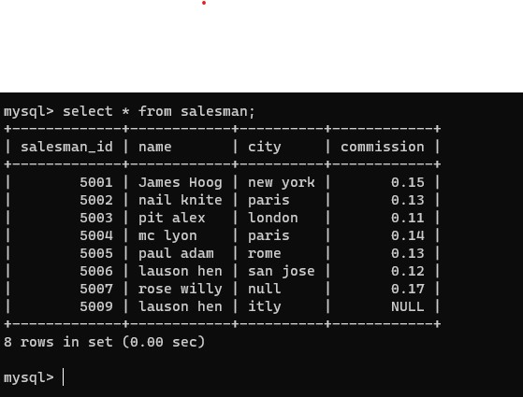

2.Write a SQL statement to display specific columns such as names and commissions for all salespeople.

select name , commission from salesman;

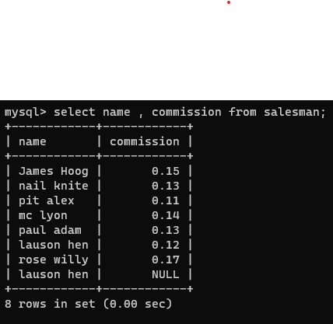

3.write a SQL query to locate salespeople who live in the city of 'Paris'. Return salesperson's name, city.

select name , city from salesman where city='paris';

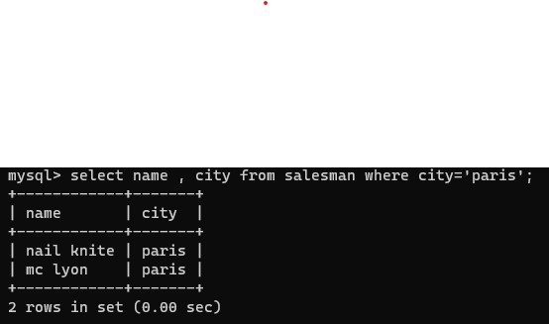

4.write a SQL query to locate salespeople who live in the city of 'San Jose'. Return salesperson's name, commission.

select name , commission from salesman where city='san jose';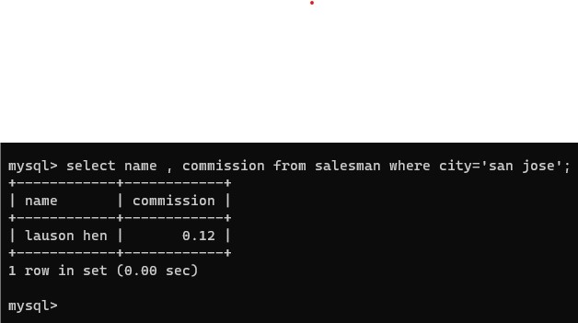

5.Write a SQL statement to display columns such as salesman_id ,names and city for all salespeople.

select salesman_id , name , city from salesman;

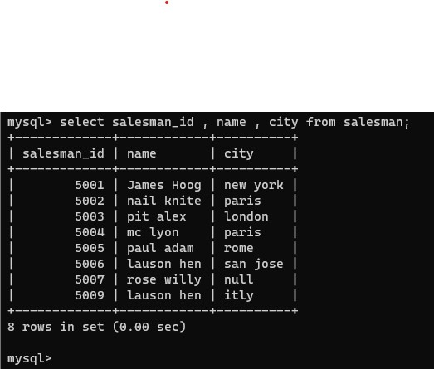

6.Write a SQL query to display columns such as salesman_id ,names and city for all salespeople.

select salesman_id , name , city from salesman;



7.Write a SQL statement that displays all the information Arranged the output in ascending order by name.

Select * from salesman order by name asc;

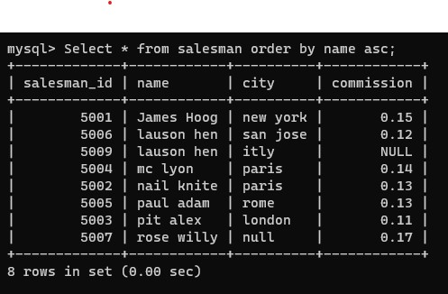

8.Write a SQL statement that displays all the information Arranged the output in ascending order by salesman_id

Select * from salesman order by salesman_id asc;

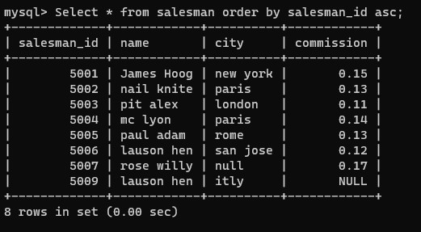

9.Write a SQL statement that displays all the information Sort the output in descending order on salesman_id.

Select * from salesman order by salesman_id desc;

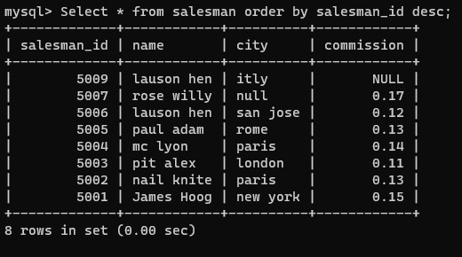

10.Write a SQL statement that displays all the information who live in the city of 'San Jose' AND 'Paris' Sort the output in descending order on salesman_id.

Select * from salesman where city = 'San Jose' or city = 'Paris' order by salesman_id desc;

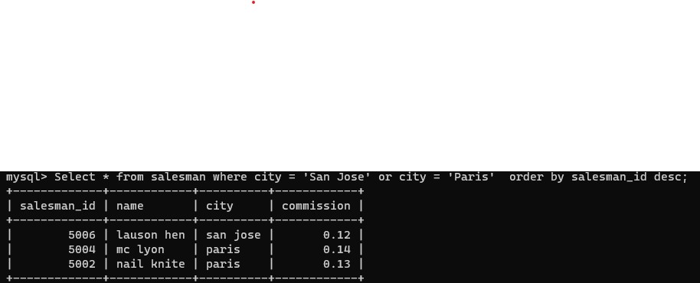

11.write a SQL query to locate who live in the city of 'San Jose' AND 'Paris' Sort the output in ascending order on salesman_id.

select * from salesman where city='san jose' or city='paris' order by salesman_id asc;

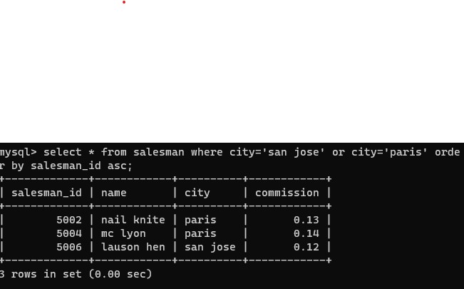

12.Write a SQL statement who live in the city of 'San Jose' AND 'Paris' Sort the output in descending order on name

select * from salesman where city='san jose' or city='paris' order by name desc;

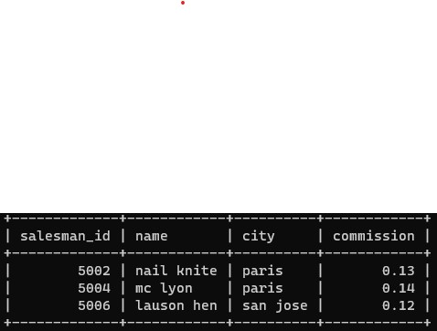

13.write a SQL query to locate who live in the city of 'Rome' OR'London' Sort the output in ascending order on salesman_id.

select salesman_id from salesman where city in ('Rome', 'London') order by salesman_id asc;

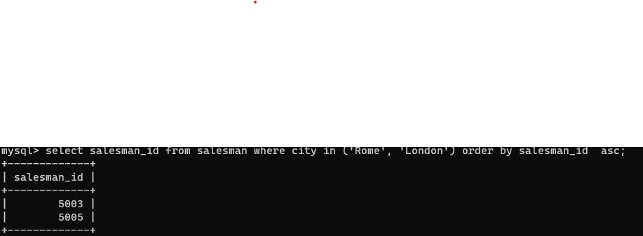

14.write a SQL query to locate who live in the city of 'New York' OR'London' Sort the output in ascending order on city ?

select city , name from salesman where city='new york' or city='london' order by city asc;

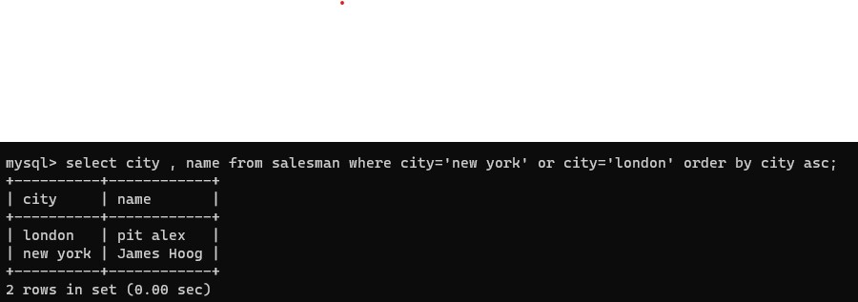

15.write a SQL query to locate who live in the name of 'James Hoog' OR 'Paul Adam' Sort the output in ascending order on commission.

select name , commission from salesman where name='james hoog' or name='paul adam' order by commission asc;

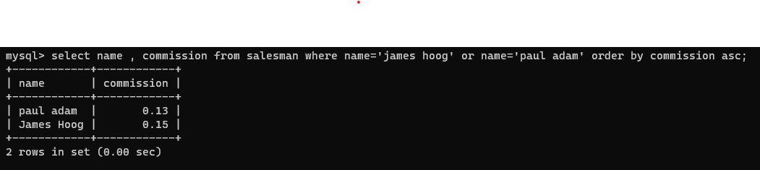

16.Write a SQL statement to display specific columns such as names and commissions,city for all salespeople having commission 0.13.

17.Write a SQL statement to display specific columns such as names and commissions for all salespeople having commission greater than 0.12.

select name, commission from salesman where commission > 0.12;

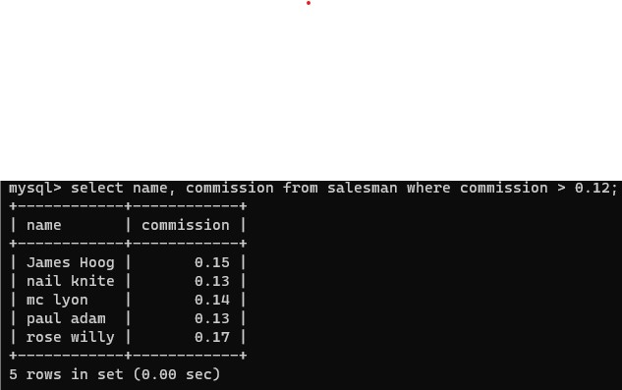

18.Write a SQL statement to display all salespeople having commission greater than 0.12.

select name, commission from salesman where commission > 0.12;



19.Write a SQL statement that displays all the information salespeople having city is NULL.

select * from salesman where city='null';

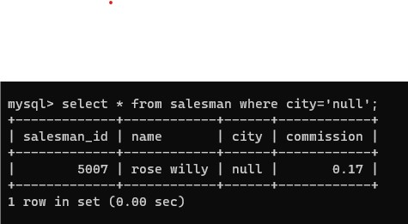

20.Write a SQL statement that displays all the information salespeople having commission is NULL.